ANNUAL REPORT
2013-2014
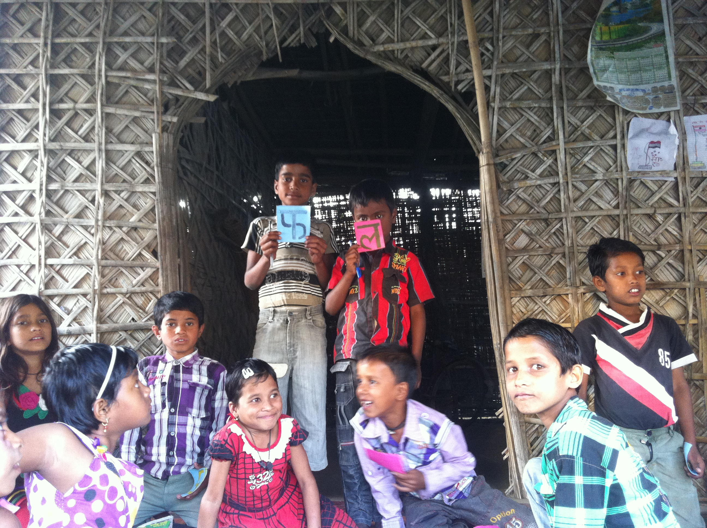
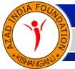
AZAD INDIA FOUNDATION
LINE MOHALLA , KISHANGANJ
BIHAR-855107

VISION STATEMENT: AIF is committed to the goal of enabling individuals to realize their full potential and to lead prosperous lives in a self reliant and harmonious community.
Achievements of Azad India Foundation 2013-2014
- 500 children received primary education under National institute for Open Learning for Level III.
- 2934 children received education in 40 Madarasas .
- 1539 children received preschool education at the Madarasas.
- 860 children were given remedial classes under Right to Education Act.
- 50 Girls Learning Centres running with 1615 girls receiving primary education.
- 1809 women and adolescent girls above 14 years underwent functional literacy classes.
- 360 adolescent girls attended life skills and health sessions.
- 102 Maulanas and madarasa teachers trained on nonformal education.
- 62 libraries functioning in non formal centres in different villages.
- 89 children received formal primary education.
- 32 children received primary education under sponsorship from friends of AIF.
- 53 girls received vocational training in basic stitching and tailoring.
- 33 girls started working after completing stitching and tailoring course.
- 233 girls and boys completed Basic Computer Course.
- 25 New Child Learning Centres set with 877 children receiving primary education.
- Education and literacy Interventions started in Thakurganj and Kochadaman blocks

MISSION STATEMENT: Empowerment of grass root communities for their betterment with active participation of rural women.

Transforming lives through Education
Azad Public School
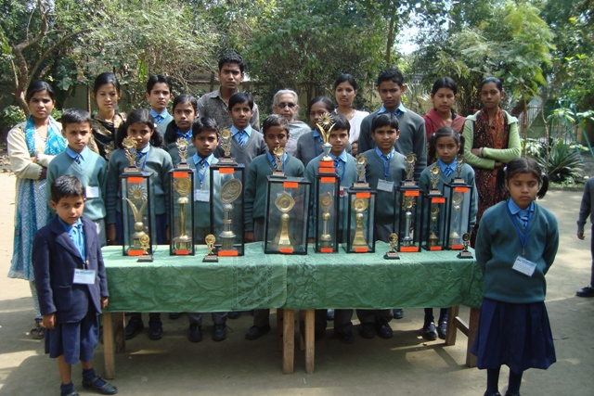
Winners of District Level Chess Competition with their trophies

Azad India Foundation believes that education is the true means of socio-economic and intellectual advancement of society. Every child, in the least, deserves primary education irrespective of caste, religion or socio-economic background. APS aims at developing the optimum mental and physical potential of each and every child. The school has introduced contemporary education and training methods to train and educate children in a non stressful and pleasant environment.
Azad India Foundation provides freeships and sponsorships to poor and needy students studying in the school. The whole idea is to provide quality education to as many children as possible. AIF also has fee concessions for deserving students by way of subsidized tuition fee for different income groups. This way we try to imbibe a feel of competition and self worth among deserving children. AIF has received tremendous support from organisations, well-wishers and friends in realising the dream of providing wholesome education to the children of marginalized and underprivileged sections of society so that they may have equal opportunities to contribute to the nation’s growth.
Naaz Parween
Naaz Parween,a 10 year old daughter of a rickshaw pullar is a hard working student.She has 4 brothers and 1 sister.Naaz joined Azad Public School in Class Nursery. She has shown consistent improvement in her studies.Azad India Foundation sponsored her education with donation received from Ms Anju Chaddha

Project Talim Supported by The J.R .D Tata Trust
Azad India Foundation represents an approach to education that emphasizes the development of children’s abilities as well as their rational understanding. AIF believes that the main purpose of education is to make the child self –motivated and an independent learner. The Project Talim Phase II is running in 40 villages of Pothia Block covering 40 madarasas and 28 government schools. The main focus of this phase is to ensure quality education to children studying in madarasas.

Pedagogically AIF represents an approach that emphasizes learning with understanding and learner’s active participation in the process of imbibing knowledge. The second main objective of this project is to improve the government school system by reviving the school management committees, forming parent-teacher committees and providing support staff to the schools where only 1 or 2 teachers cater to a large number of students.
AIF continued with the remedial classes to children who had directly enrolled in the government schools ensuring that they complete at least Class VIII and do not drop–out in between due to low grades or lack of motivation.
AIF also organized activities like Bal Melas in the government schools, providing children a platform to showcase their talent,spirit and confidence.

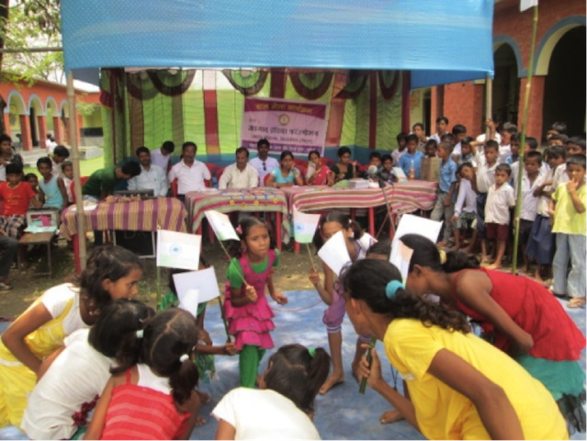
Bal Mela at Baksa High School

AIF directly reached out to 2934 madarasa children, including those children who were enrolled in government schools. 500 children who were enrolled in NIOS under Level III, successfully completed their examinations and joined Class IV in formal schools.
860 children enrolled in government schools were given remedial classes. Azad India also organized annual examination for children studying in Class I and Class II to assess their knowledge- level.

The NFE teachers extensively used learning kits sourced from Eklavya which include activities on Maths and Science and creative worksheets to engage the young learners.Monthly competency tests were done to assess the improvement in children in key subjects. Azad India maintained MIS and child profiles at all the centres.

Children who attend Remedial classes at the Madarasas
An important part of our initiative is to improve the quality of education through child centric learning and teaching techniques.The emphasis lies on activity based and playful learning. Azad India entered into an MOU with Nalanda, a resource management organisation, to organize capacity building trainings under Project Talim on various aspects of the program. The trainings were organized for six days by Mr Sanjeev Srivastav followed by Training of Trainers on Madarasa education and School Management Committee .
Azad India built capacity of 102 Maulanas and Madarasa teachers teaching in different madarasas. These teachers were trained in non-formal education and use of TLM(teachers learning material) etc. Maulanas were sent to Marwar Education Society, Udaipur on an exposure visit to get first hand experience.
AIF teachers also provided support to government teachers in schools and conducted meetings with School Management Committees and Parent –Teacher Committees.

Child Tracking Report
Azad India Foundation completed student tracking process where we tracked 5941 students who were enrolled by AIF in Madarasas and mainstreamed to formal schools from 2009 to 2013.The tracking report shows that 108 girls got married and dropped out.461 students especially boys dropped out and migrated to other places in search of work either with their families or sent out with the agents to work as labour. 314 children shifted to other madarasas within the district or outside like Allahabad,Surat,Delhi and Mumbai to get higher education.2 students were reported dead. 5056 children are continuing with their education in different classes in government schools and madarasas.
Gender Equity

In 2013-14 ,35 Women Self Help Groups formed under Project Talim saved Rs 2 lakhs and their total savings have increased to Rs 9 lakhs.From the savings they have given out Rs 6.5 lakhs as loan to their members for different entrepreneurial activities,repaying loans that have been taken from money lenders on high interest rates,maintenance of their households and other activities.AIF have made significant change in the lives of women members of Self Help Groups. AIF formed 8 new Self Help Groups in villages Ganjabari, Jhinakor, Dangibasti, Beerpur and Kakramari covering 82 women.

Wholesome education not only needs trained teachers but also aware and involved parents. Towards that need, AIF worked on capacity building of women groups working in different villages on education related issues. The literacy rate among women is very low in Kishanganj and we hope to change that with our continued and relentless efforts. It is important to inculcate the importance of education among women especially among the mothers so that they send their children to study. For this purpose AIF formed a separate team headed by one CLC and 10 literacy teachers. Girls above 14 years of age who had dropped out of school due to various factors were also a target group. Field workers interacted with the women and girls within their villages according to the time suitable to them. In all 1059 women and 316 girls were enrolled for functional literacy classes in 52 Literacy centres.

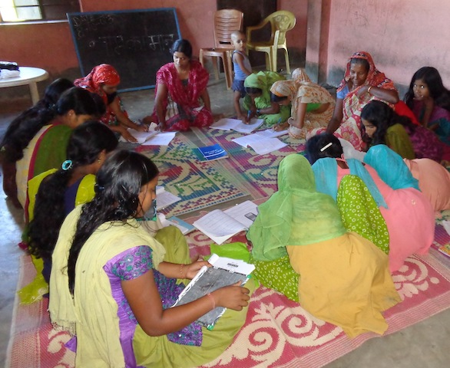
Literacy Class at Village Dangibasti

Project Alima Girl Child Learning Centres Supported by IIMPACT

Azad India Foundation in partnership with IIMPACT is running girl child learning centres in the selected 50 villages. The main focus of the program is to provide primary education to girls and then mainstreaming them towards formal schools. Creative learning and teaching techniques are a critical part of the project. These techniques help in improving the learning levels of the girls. The emphasis is on an integrative process of learning methods where the girls learn through activity based modules leading to playful learning .

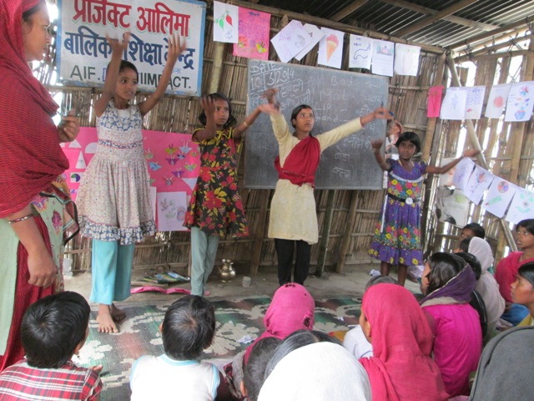
AIF-IIMPACT Girl Child Learning Centre at Village Tekna

The teaching is done through play-way methods and by using visual aids and TLMs. About 1615 girls attended our Non Formal Centres at different levels.
AIF conducted competency level test at the Learning centres where the knowledge levels of the students were examined through written and oral tests. This helped in assessing the weak students and giving them remedial classes. The teachers use several TLMs in the classrooms.
These include bamboo sticks, small pebbles, cards, chart papers and pictures. The students also contributed in making the TLMs at some centres like Kesojhara. Azad India organized capacity building programs for the Project team members at regular intervals to enhance the efficiency of the teachers. Mr GV R Prasad, resource person from Sahaj, Ranchi conducted training programs.

Girls in Different Levels of Learning
He discussed various aspects of non-formal education including community-mobilization, communication skills, use of TLMs, confidence building and preparing curriculum and different class activities.
Azad India Foundation also organized Centre Management Committee meetings in the intervention area. More than 150 meetings were organized in 50 centres. The main points of discussion include attendance of students at the centres, quality of education,maintenance of the shed etc.
The project team members regularly interacted with the parents of the girls involving them in the learning process of their children through sharing of assessment reports,activities etc.

Azad India organized many activities at the Learning Centres including drawing competitions, sport days and special days like Gandhi Jayanti, Childrens Day, Republic Day etc where the girls participated with full enthusiasm and confidence. Parents were also invited to these special day celebrations.
This not only gave students an opportunity to show their talent and develop confidence but also encouraged them to take an active interest in national days.
A feeling of nationhood and belongingness to mainstream India was also a positive fallout of these events for students, teachers and parents.

Project Badhte Kadam supported by Nalanda Charitable Foundation

Azad India Foundation with support from Nalanda Charitable Foundation set up 25 Child Learning Centres in selected villages in Thakurganj block.

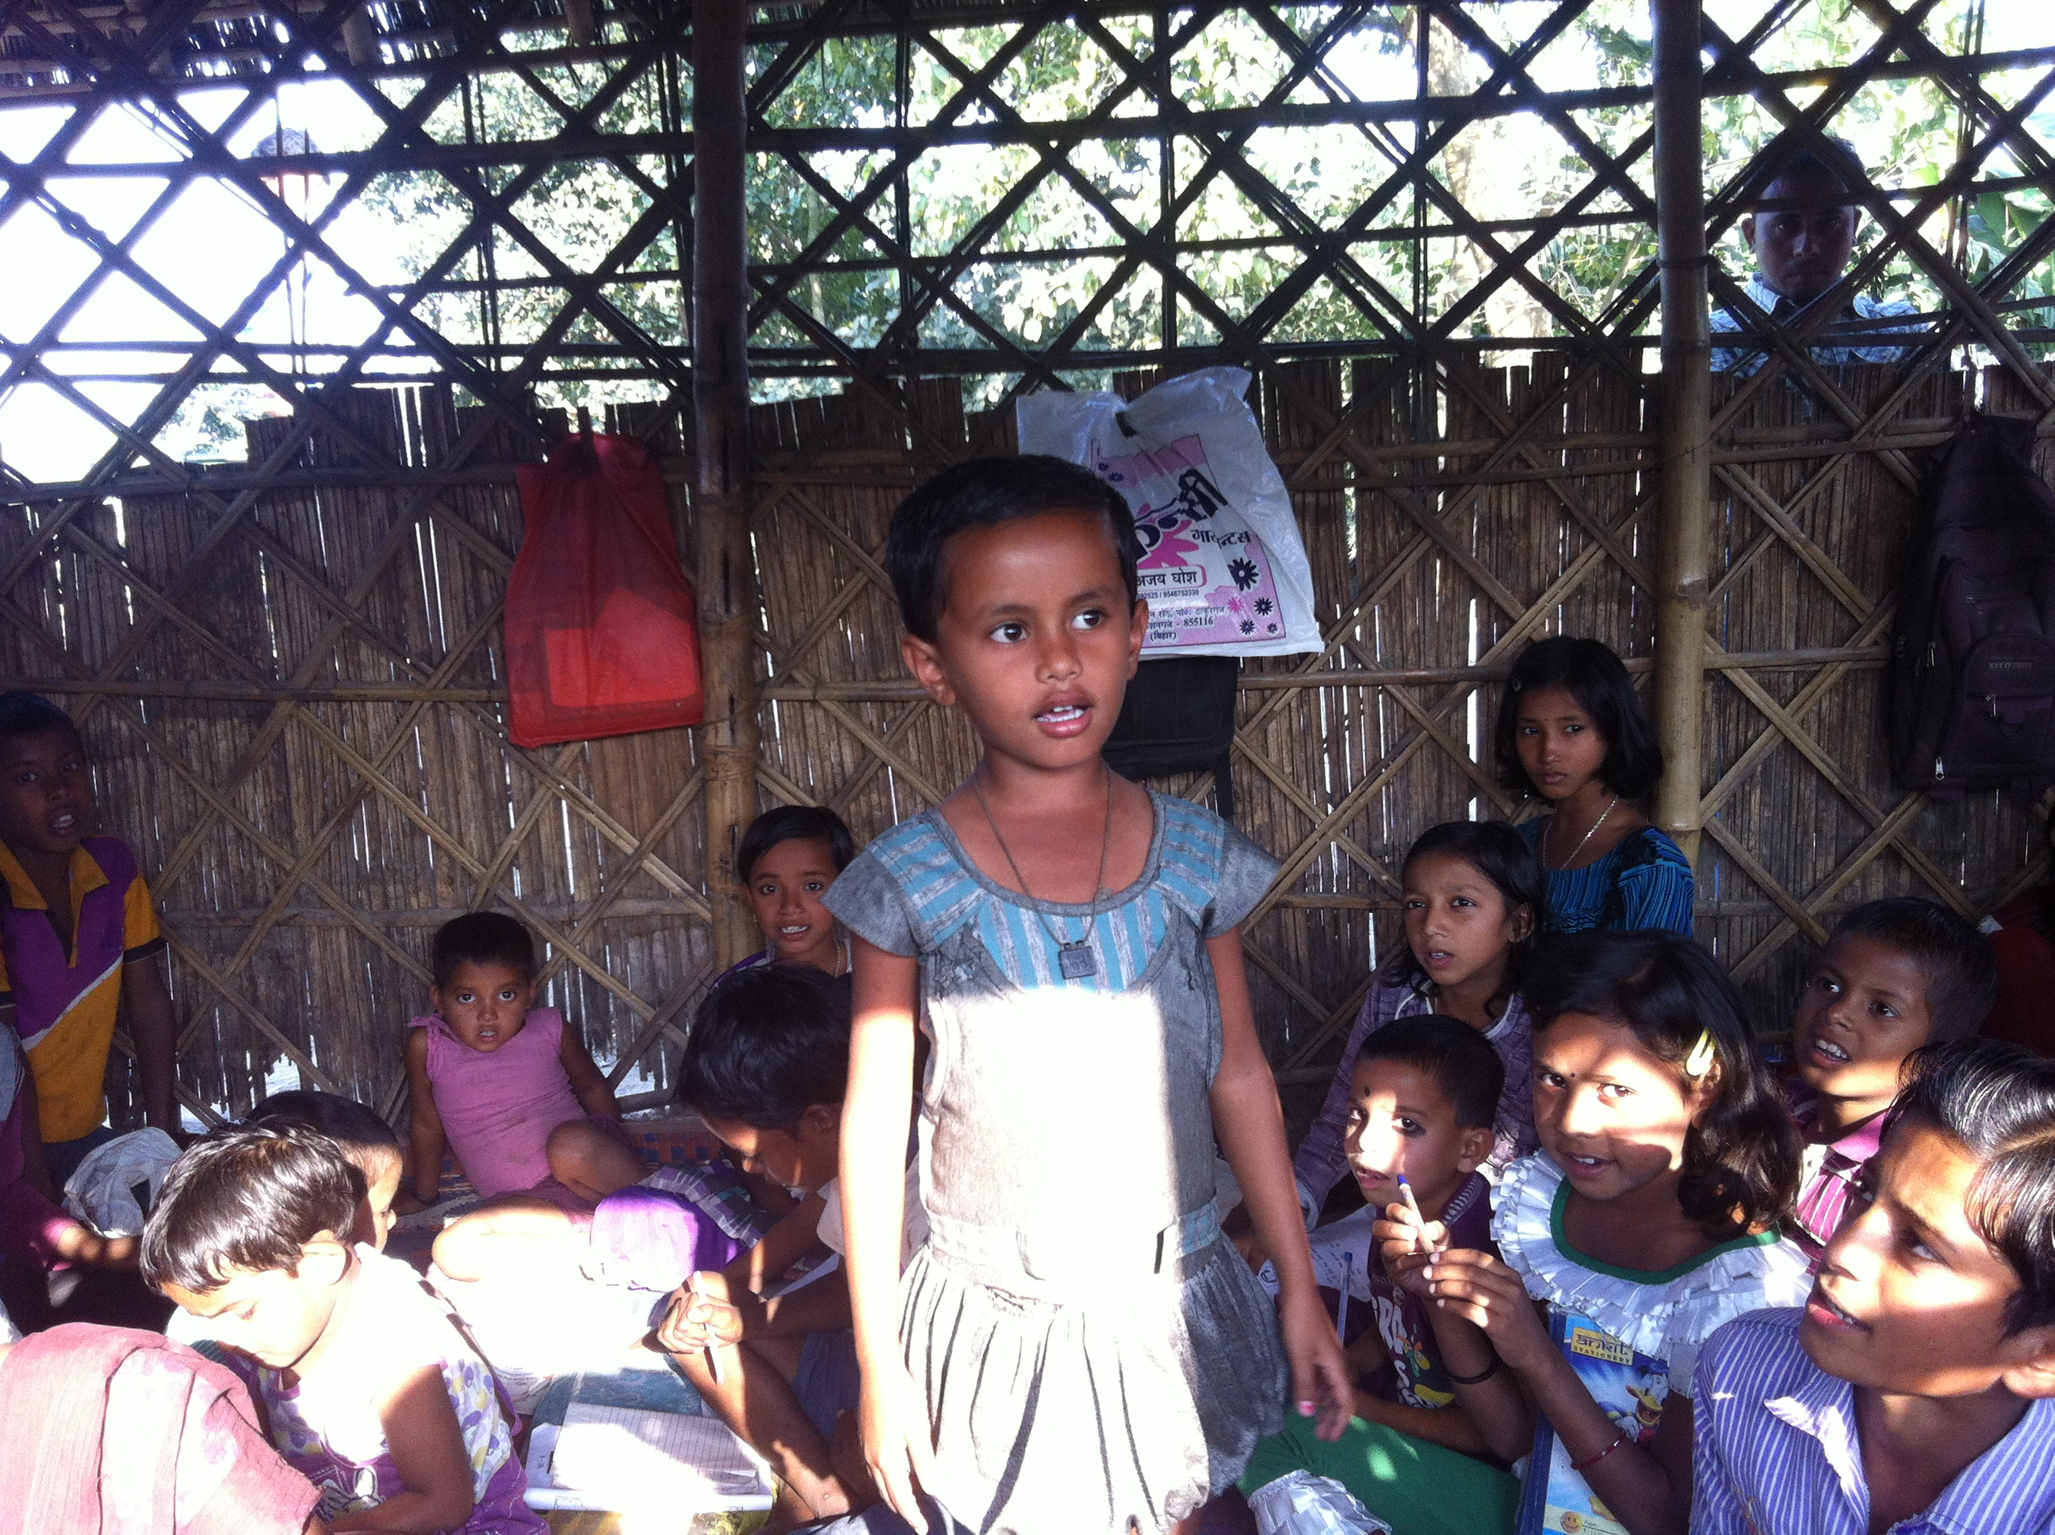
AIF –NCF Child Learning Center at Village Patesary

The main focus of the program is to provide primary education to the children from age-group 6-14 and mainstreaming them to formal schools. In the first year, 477 boys and 400 girls attended the centres.
The children have varying pace of learning and hence the centres are organized in learning groups that are multi level and multi age in composition. The teachers keep records of children and try to chart out a course of learning suitable for each individual child within the curricular framework.Many activities were organized at the centers.
The project team underwent quarterly teachers training in padagogy and teaching methodologies from Mr Sheesh Ram a senior resource person from Rajasthan.

Bringing Children and Books Together –Through Pratham Reading Sessions
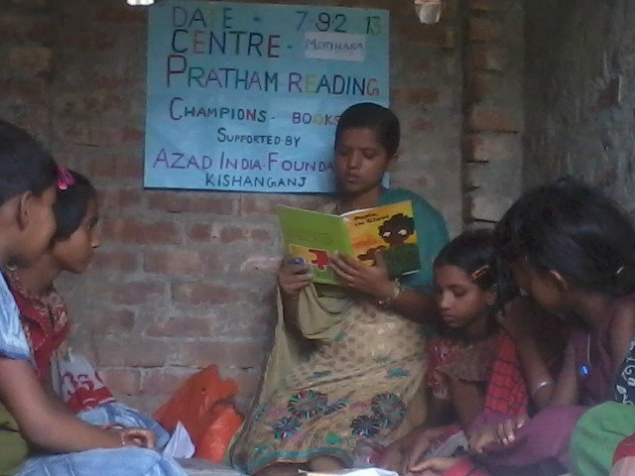
Pratham Book Reading Session at Motihara AIF-IIMPACT Girl Child Learning Centre

Azad India Foundation organized reading sessions on 7th September on the occasion of International Literacy Day at 40 Nonformal Centers under Project Talim and Project Aalima Girl Child Learning Centers. 40 teachers, 7 cluster level coordinators and 1282 children read, listened and narrated the book ‘Paplu the Giant’ in English and Hindi.
The day was full of excitement at the centers as preparation for the D- Day had started almost a week before. This small step of Pratham Books brought joy of reading to so many children.

Library-in-a-classroom grant from Pratham

Azad India Foundation won Library in a Classroom grant from Pratham Books. Seven Library kits with colorful books were given to AIF- IIMPACT Girl Child Learning Centers of Bisani, Dehalbari, Motihara, Tekna, Kasipur, Panisal and Dhekipara. The children were thrilled to get books and enjoyed reading sessions with the teachers.
With this grant ,Azad India Foundation has set up 22 Libraries in Girl Child Learning Centres.Library sessions have become integral part of the learning process as they enhance the creativity and reading skills of the children.
Women Literacy Program
Project Pahla Kadam supported by Sir Dorabji Tata Trust, Mumbai
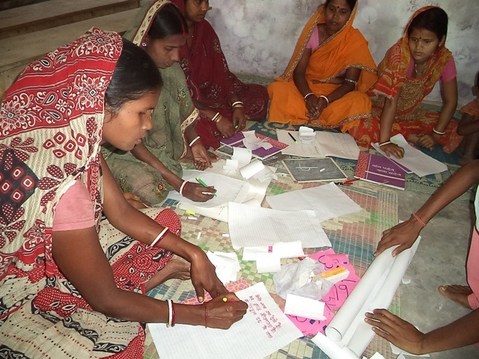
Literacy Centre at Village Kauwaura

Azad India Foundation believes that when women are educated, a transformation begins. Education enables women to become central agents of social change, changing the future of their children and their families for the better.
With this objective in mind, Azad India Foundation started a women’s literacy program in 15 villages of Kochadaman block. With technical support from Nirantar, a Delhi based organization, Azad India set up 30 Literacy centres with 750 women.
The women were organized in self-help groups to facilitate easy learning along with focus on saving and thrift.
The centres ran in two batches according to the time suitable to the women. Azad India Foundation organized intensive meetings with community members to convince women to attend literacy classes.

Peace and Social Justice
Project Rehnuma (supported by National Foundation for India and Centre for Social Justice)

The Rehnuma initiative entailed setting up of an entitlement centre in village Singhia under the MSDP program in minority concentrated districts of India with technical support from the Centre for Social Justice Ahmedabad. Azad India Foundation is covering 30 villages in 11 panchayats.
The Rehnuma project team supported by a lawyer has undertaken various awareness programes to popularize the government schemes meant for the minorities. They also give information and guidence to the community members including the marginalized ones, on laws and claims. The team members attended capacity building and perspective building workshops organized by the Centre for Social Justice at regular intervals.
The Rehuma project team organized 180 community meetings with 2356 members. 64 workshops were organized with lawyers on human rights and social justice issues. 91 Paralegals were identified and 18 orientation workshops were done with them.
The team members filled 52 RTIs with different government departments and got replies on 46 queries. Azad India helped filling up of 1750 pre and post Matric scholarships with the students of secondary and high schools.
About 300 applications were filled with Rozgar Sewak on Jobcard under MNREGA (Mahatama Gandhi Rural Employment Gurantee Scheme). The lawyer attached with Rehnuma team gave free legal advice to 1336 people.
About 40 loans under National Minority Finance Development Scheme got sanctioned. The Rehnuma team members successfully got 9 new Anganbari Kendras opened in different village

Skill Development
It is accepted that education, learning and skill development are critical for the progress and growth of the country. With exposure to the media, the rural youth today aspire to have the same opportunities for growth as their urban counterparts. For this, they not only require good education and knowledge but also skills which make them employable. In these developing times, Information Technology skills are essential for any one wanting to take up employment. Keeping these objectives in the fore front, Azad India Foundation is running two computer centres in Kishanganj.

Computer Centre Supported by The J.R.D Tata Trust

Azad India Foundation set up a computer centre with 4 computers at village Chattargach for rural girls. Chattargach is the local hub for commercial activity for many neighbouring villages.
Azad India Foundation has entered into partnership with NIIT Foundation promoted by NIIT to give more structured curriculum and certification to the students.
Azad India also encouraged the children studying in nearby madarasas to join the computer centre. In the 2013-14, 183 girls successfully completed the course.

The main topics covered under the course are MS office, MS Paint, History of Computer, Internet and Email etc.

Computer Centre Supported by Sud Chemie India Pvt Ltd

Azad India Foundation has set up a second computer centre with four computers for students especially girls from the disadvantaged sections of the society at Anjuman-I-Islamia Kishanganj from July.
The centre is running a three months basic computer application course accredited by NIIT Foundation. Two batches of 25 students each,have successfully completed their course.

Stitching Centre
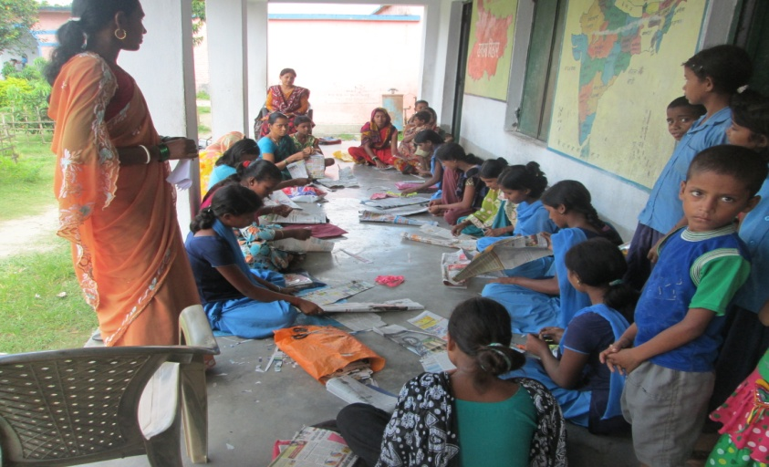
Stitching center at Village Balubari

AIF ran 3 batches of cutting and tailoring and literacy classes for adolescent girls in different villages of Das tola Motihara, Nayabasti Motihara and Balubari to teach income generating skills. About 53 girls learnt basic cutting and stitching skills with the aim of enabling them to supplement their income. Azad India Foundation gave sewing machines to Guria Bhowmick, Saleha Khatoon and Seema Khatoon who belong to very poor families.

Case Study
Guria Bhowmick is a 16 years old girl. She is the eldest of her eight siblings. Her father died a few years ago and her mother works as a labourer to look after the family. When Azad India Foundation opened a stitching centre near her village, Guria enrolled in the basic stitching and tailoring course. As she was a bright and hard working girl and her family’s economic condition was really dismal, Azad India Foundation decided to sponsor a sewing machine.
Guria started stitching within the village and later got work from neighbouring villages as well. Now she is earning at least Rs. 3000-4000 per month and helping her mother. She is sending her younger brothers to school, who were previously forced to drop-out.

Improving Health and Sanitation
Project Axshya (for eradication and prevention of Tuberculosis) supported by Bihar Voluntary Health Association, Patna

Azad India in partnership with the Bihar Voluntary Health Association (Patna), started an awareness program on Tuberculosis in selected villages of Pothia block. The aim of this 5 year program is to make the community aware of TB, its causes and the methods of prevention and cure. The program also identified potential TB patients and sent them for sputum tests. They were given information on DOTS and its availability in PHCs. AIF conducted 5 meetings with community members and 38 meetings with village health and sanitation committees where 990 people participated.

Adolescent Girl Literacy and Health Program supported by Aga Khan Foundation, New Delhi
Azad India Foundation with support from the Aga Khan Foundation started adolescent girl’s literacy and health program in selected 12 villages covering three panchayats of Sarogora, Budhra and Naukatta of Pothia block. The main focus of the program is empowerment of girls through knowledge on life skills, reproductive health and functional literacy.
The program covers 360 girls in two batches per villages in the first phase. Azad India Foundation conducted 60 meetings with the girl’s parents and 41 meetings with mothers. 73 meetings were also done with community members. Nirantar provided the technical expertise to the program, with capacity building of the project team.

AIF Awareness Program on Health and Sanitation
Azad India Foundation organized 35 awareness programs on health and sanitation issues in its intervention area. The main focus of the program was to inform people about healthy practices and about maintaining self hygiene. Another objective was to reduce incidents of water-borne diseases especially among young children. The awareness programs were conducted by Md Alim, Md Iqbal and Md Ajmal in different villages. A total of 416 community members participated in the meetings.

AIF Awareness Program on Anti –Trafficking
Azad India Foundation organized awareness meetings on Anti-trafficking in many villages in Kishanganj. In recent years, Kishanganj especially Pothia block have become the centre of trafficking where several girls and children have gone missing on the pretexts of marriages and jobs. They are either trafficked to big cities like Delhi and Mumbai to work as labour or if they are young girls they are forced into prostitution.

31 meetings were organized where 367 girls and women participated. They were given information to on how to look out for traffickers within their community, or among outsiders who visit their villages, and report them immediately to village elders and field workers.
Visitors to Azad India Foundation
Mr R U Prasad from Nalanda Charitable Trust
Ms Saraswati Padmanabhan from Sir Dorabji Tata Trust, Mumbai
Mr Rajesh from IIMPACT Gurgaon
Ms Shevata and Ms Asha Pathak from Centre for Social Justice, Gujarat
Mr Abdul Jalil from Masud Charitable Foundation, Assam
Mr Akhilesh Kumar Srivastava, Assessor Credibility Alliance
Mr Sanjay Biswas from Aga Khan Foundation, Patna

Azad India Foundation is growing with the contributions of the following donors
Donor Agencies:
- The JRD Tata Trust – Mumbai
- Sir Dorabji Tata Trust - Mumbai
- IIMPACT – Gurgaon
- Nalanda Charitable Foundation - Mumbai
- Aga Khan Foundation - New Delhi
- National Foundation for India - New Delhi
- Bihar Voluntary Health Association - Patna

Corporate Sponsorship:

Sud Chemie India Pvt Ltd - New Delhi
Nalanda Capital Pvt Ltd - Mumbai

We value the help and contributions of following friends in carrying out our activities
- Mr and Mrs Iskandar Laljee - New Delhi
- Mr Alak Raju – New Delhi
- Mrs Madhuri Raju - New Delhi
- Mr and Mrs Arun Mehra - UK
- Mrs Ritu Singh - New Delhi
- Mr Dilip Puri – New Delhi
- Mrs Anju and Rajan Kumar Chadha - UK
- Ms Rupali Bhushan - New Delhi
- Mrs Nigar Farooqui - NOIDA
- Mr Mazrul Islam – Kishanganj
- Mrs Yasmin Begum – Kishanganj
- Mr Iqbal Hasan - Kishanganj
- Mr Sohail Ahmad - Kishanganj
“Azad India Foundation is accredited by Credibility Alliance for desirable norms.”
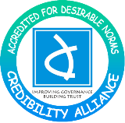
Accreditation valid from “27th March 2014 to 26th March 2019”

Networks
Azad India is a member of Guide Star India with GSN: 326
Azad India Foundation is member of Bihar Voluntary Health Association, Patna.
Azad India is listed on Planning Commission’s Website : BR/2012/0052454
Azad India is partner of NIIT Foundation
Azad India is accredited agency of National Institute of Open School
Identity of Azad India Foundation
AIF is registered as not for profit under Society’s Act 21, 1860 (Reg No 145 dtd June, 21 2001)
MOA is available on request
AIF is registered u/s 12 A of the Income Tax Act 1961 and with the IT exemption 80G once granted shall continue to be valid in perpetuity unless specifically withdrawn wide finance(No.2) Act2009 with effect from 1st oct.2009
AIF is registered under section 6(1) (a) of the Foreign Contribution (Regulation) Act, 1976 (FCRA Reg no: 030910003)
AIF pan no is AAATA7787J
Name and Address of Our banker:
United bank of India, Dey Market, Kishanganj
Name and Address of Auditor:
Jha & Associates, Chartered Accountants, Flat no 406-407, Grand Plaza, 4th Floor, Frazer Road, Patna 800001
Registered Address of Azad India Foundation:
Azad Manzil, Line Mohalla, Kishanganj, Bihar, 06456-222483
Website: http://www.azadindia.org
Email: aif_org@yahoo.co.in

Facebook : http://facebook.com/azadindiafoundation
Twitter : twitter.com@kishanganjazad1
Governance of Azad India Foundation
Details of the Board Members (as on March 31, 2014)
Name | Age | Sex | Position onboard | Occupation | Meetings attended
Mrs. Sayeeda Banu | 64 | F | Chairperson | Social Work & Agriculture | 3/3
Mrs. Yuman Hussain | 40 | F | Executive Director related to Chairperson | NGO professional | 3/3
Mr. Farahatullah | 74 | M | Treasurer | Social Work | 2/3
Dr. Govardhan Singh Rathore | 50 | M | Director | Doctor | 1/3
Mr. Iskander Lalljee | 50 | M | Director | Industrialist SudChemie India Pvt.Ltd | 3/3
Mr. Alak Raju | 49 | M | Director | Businessman | 2/3
Ms. Rupali Bhushan | 40 | F | Director | CEO  Yaxiyan Language Services | 0/3
- The AIF Board met 3 times in the FY 2013-14 on 09.5.2013, 18.9.2013 and 31.1.2014
- Minutes of Board meetings are documented and circulated.
- A Board Rotation Policy exists and is practised.
- The Board approves programmes, budgets, annual activity reports and audited financial statements.
- The Board ensures the organization’s compliance with laws and regulations.

Accountability and Transparency
Salary is being paid to the Executive Director and an Honorarium is paid to the Treasurer. No other remuneration, sitting fees or any other form of compensation has been paid to any board member.
The following reimbursements have been made to Board members:
- Travelling Expenses to attend Board Meetings - Nil
- No other reimbursements have been made to any Board Member
- Executive Director’s Remuneration is Rs. 30,000/Per Month
- Honorarium to Treasurer is Rs 4000/Per Month
- Remuneration of three highest paid staff members:
Rs. 20,000/-, Rs. 11,000/- , Rs. 8,000/- per month
- Remuneration of the lowest paid staff member: Rs. 1200/-
- Total cost of International travel by all staff during the year is nil.
- Total cost of national travel by staff/Board Members is Rs.28070/-

Azad India Foundation Staff Details (as at March 31, 2014)
Azad India Foundation is proud of its team members and value their dedication towards the organization.
Gender | Paid Employees Full time (Contract Basis) | Paid Employees Part Time (Contract Basis) | Paid Consultants | Un Paid Volunteers
Male | 82 | 0 | 3 | 0
Female | 98 | 12 | 0 | 0

Distribution of staff according to salary levels along with benefits
(as at March 31, 2014)
Slab of gross salary plus benefits  (Rs per month) | Male | Female | Total
˂ 5000 | 19 | 96 | 115
5,000 – 10,000 | 58 | 13 | 71
10,000 – 25,000 | 5 | 0 | 5
25,000 – 50,000 | 0 | 1 | 1
1,00,000 ˃ | 0 | 0 | 0
Total |  |  | 192

